BUSINESS REPORT by SHUBHANK KATAREY (PGP-DSBA)
MACHINE LEARNING PROJECT

Machine Learning

Problem 1:
You are hired by one of the leading news channels CNBE who wants to analyze recent elections. This survey was conducted on 1525 voters with 9 variables. You have to build a model, to predict which party a voter will vote for on the basis of the given information, to create an exit poll that will help in predicting overall win and seats covered by a particular party.
Data dictionary:
Vote: party choice: conservative or labour
Age: in years
economic.cond.national: assessment of current national economic conditions, 1 to 5.
economic.cond.household: assessment of current household economic conditions, 1 to 5.
Blair: assessment of the labour leader, 1 to 5.
Hague: assessment of the conservative leader, 1 to 5.
Europe: an 11-point scale that measures respondents' attitudes toward European integration. High scores represent ‘eurosceptic’ sentiment.
political.knowledge: knowledge of parties' positions on European integration, 0 to 3.
Gender: female or male.

1.1 Read the dataset. Do the descriptive statistics and do the null value condition check. Write an inference on it.

Head of the dataset:

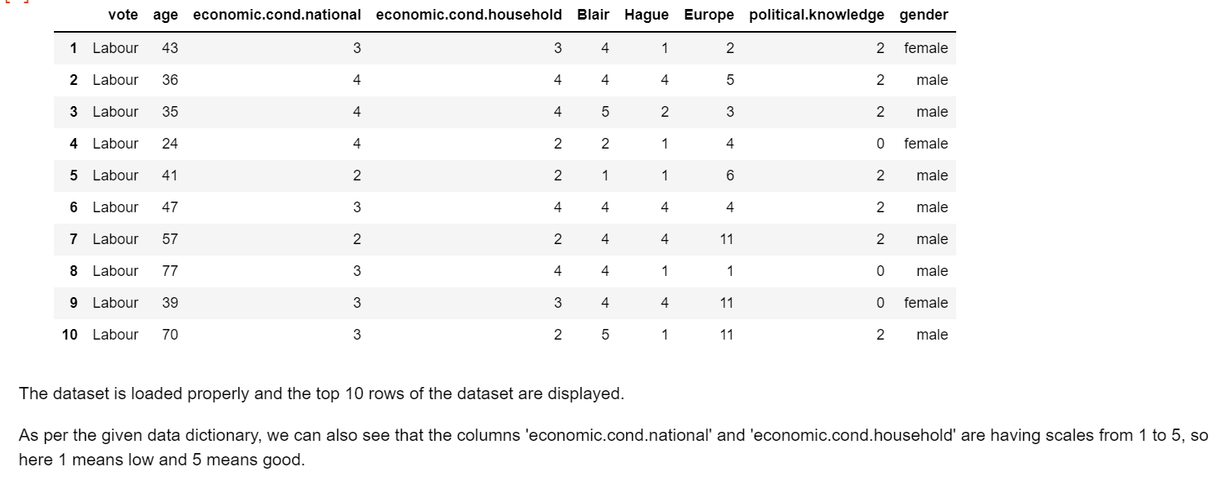

Tail of the dataset:
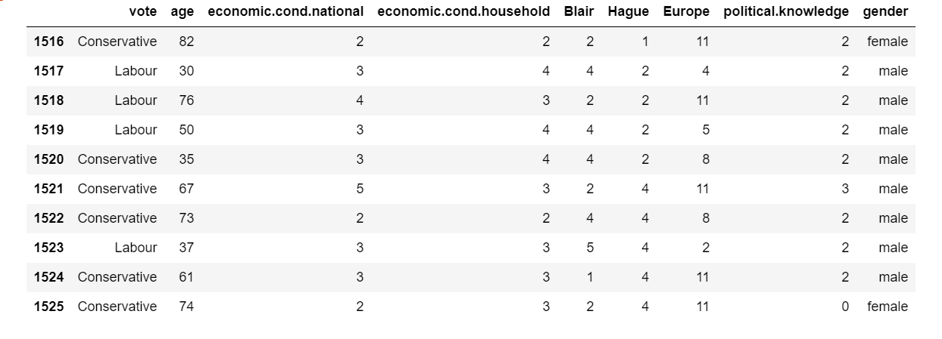
Shape of the dataset:
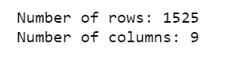
Columns in the dataset:
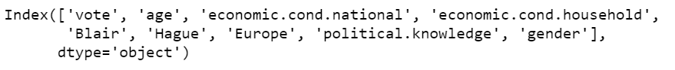

Data types in the dataset:
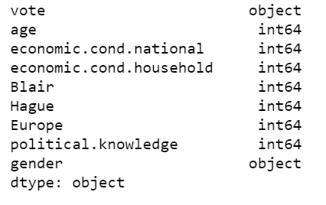

Description of the dataset:
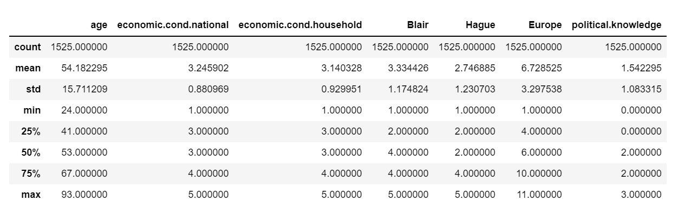

Few Observations based on Description:
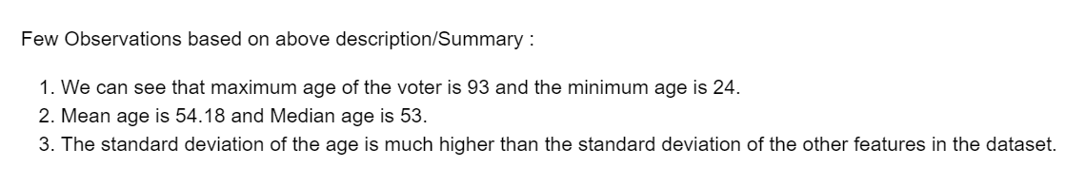

Information about the dataset:
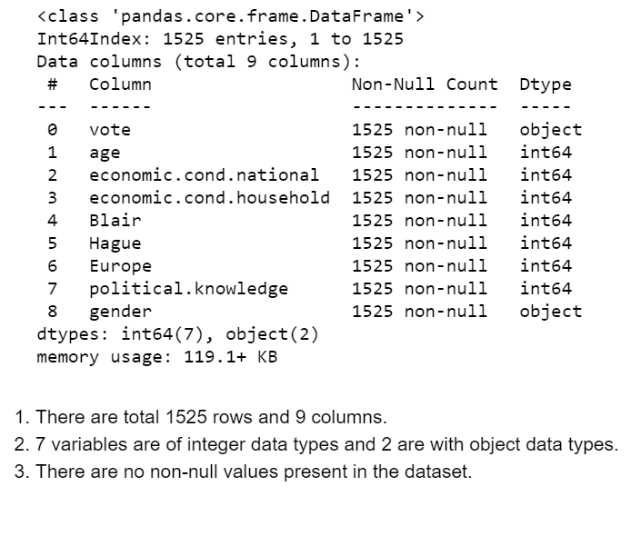

Number of Duplicates in the dataset:

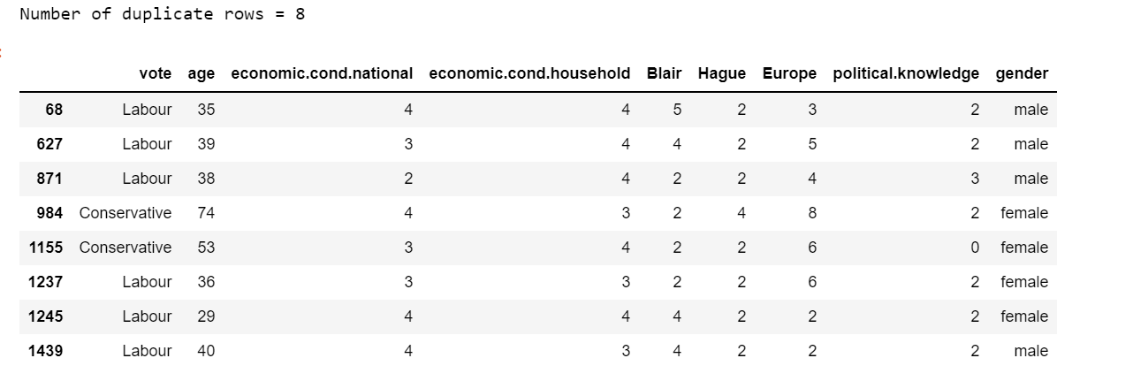

Shape of the dataset after removing the duplicates:
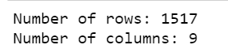

Null or missing values check:
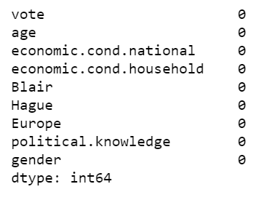

Checking vote counts:
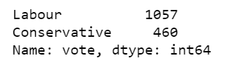

Checking gender counts:
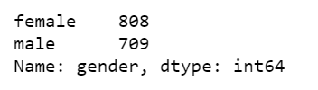

Histogram for the numeric columns in the dataset:
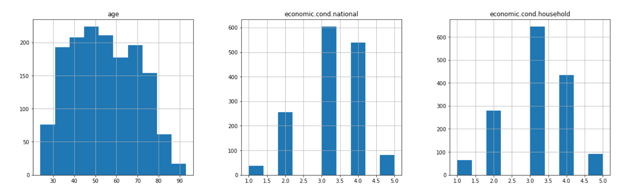

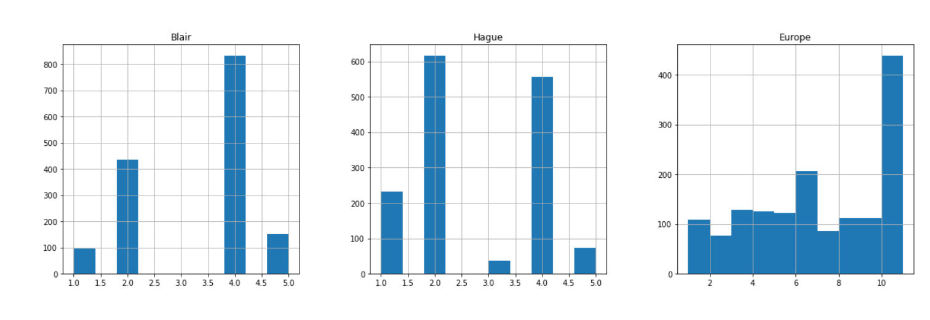
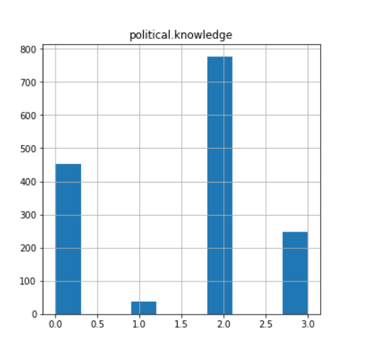

Distribution plots:

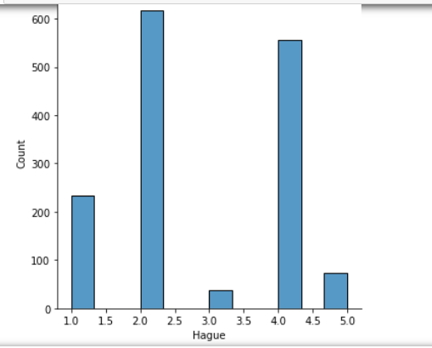
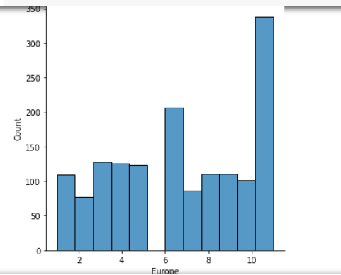

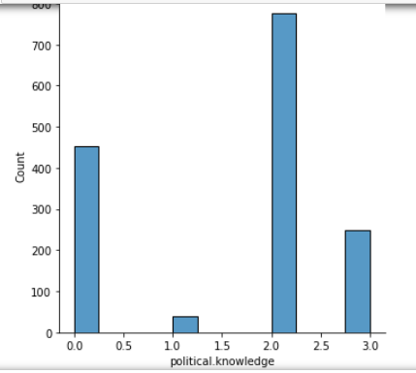

Box plot to show outliers:

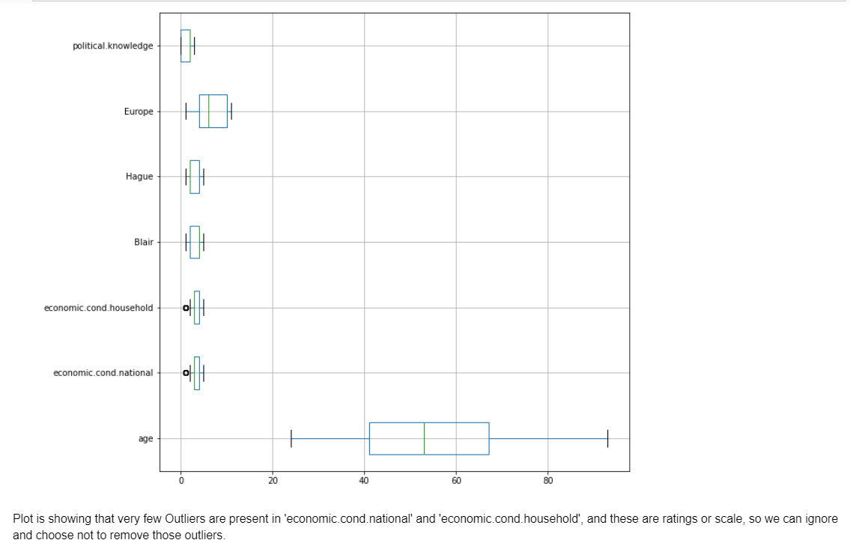

Pair plot:
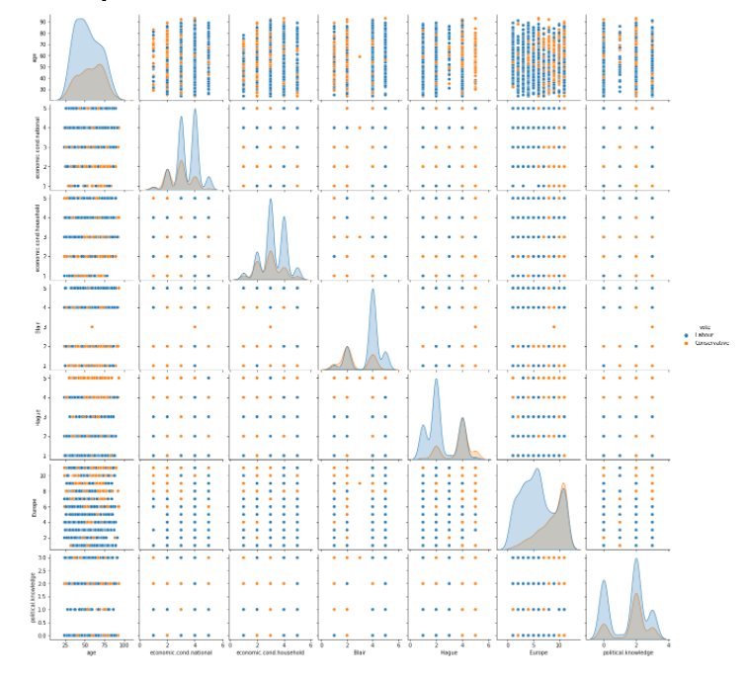

Heat map:

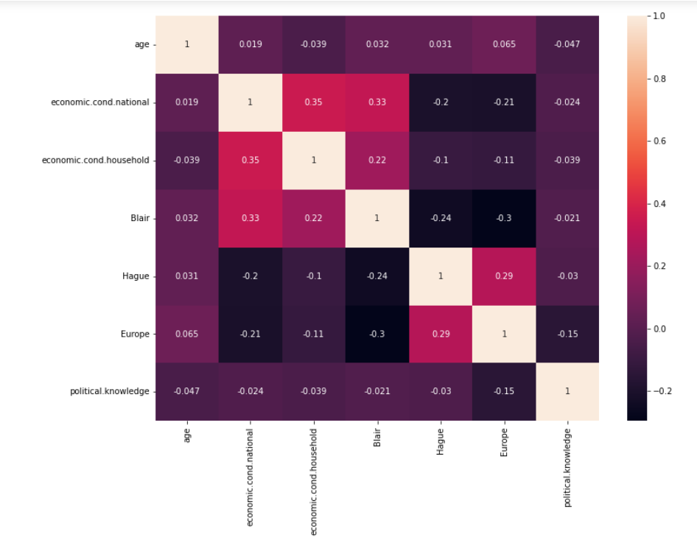

Bar plot:

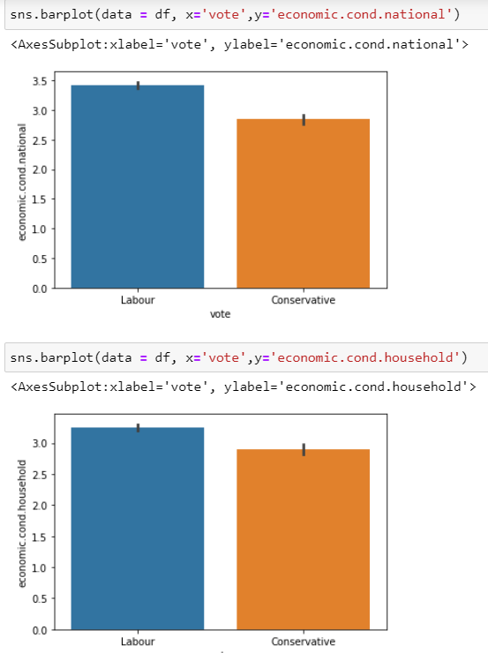

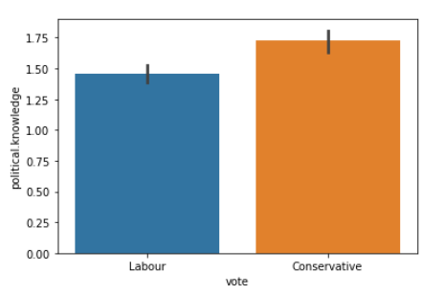

Count plot:

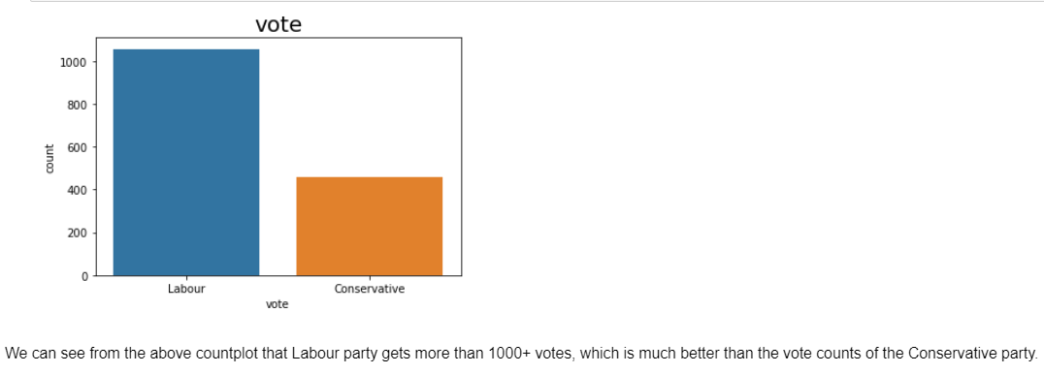

Columns with different data types:

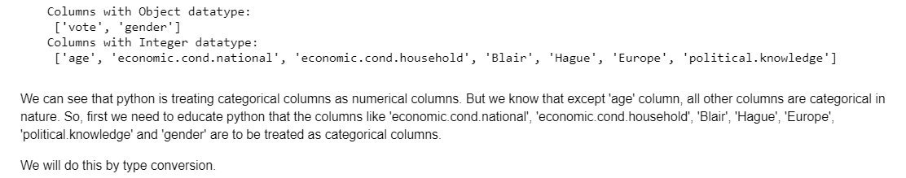

After type conversion of the columns:

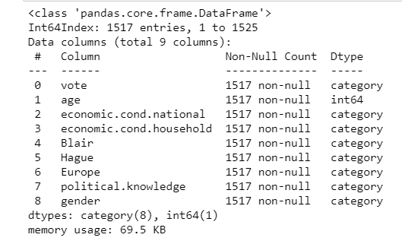

Get dummies:

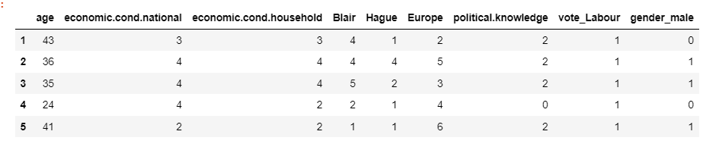

Scaling of the data:
Scaling of the data comes under the set of steps of data pre-processing when we are performing machine learning algorithms in the data set. Data standardization is the process of rescaling the attributes so that they have mean as 0 and variance as 1. The ultimate goal to perform standardization is to bring down all the features to a common scale without distorting the differences in the range of the values.
To bring all features in the same standing, we need to do scaling so that one significant number does not impact the model just because of their large magnitude.
Features scaling is necessary for this dataset, because we have seen in the boxplot that the 'age' feature has the numeric values which are much greater than the values present in the other features of the dataset.
Also we found out from the description (describe function) of the dataset that standard deviation of the 'age' is much higher than the standard deviation of the other available features in the dataset.
So, to normalize the range of independent variables or features of data, we will be scaling our data before any further analysis.

Train set:
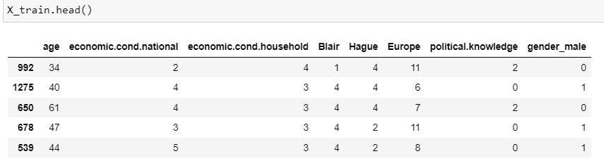

Test set:

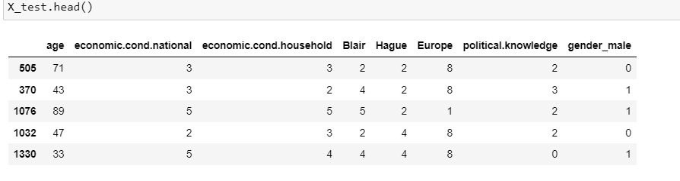

Logistic regression:

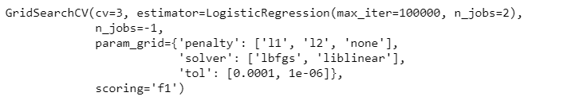
We are using GridSearchCV to get the best parameters for the model building.
Using cv (cross validation) = 3, estimator is logistic regression with maximum iteration of 100000, n_jobs = 2.

Getting the best parameters , penalty:12, solver : ‘liblinear’, tol : 0.0001

Predicting on Training and Test dataset and predicting the probabilities on test set.

Checking the head from the predicted probability.
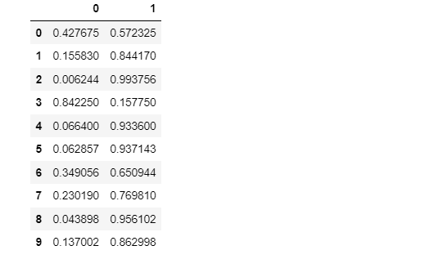
Confusion matrix:
For train data:
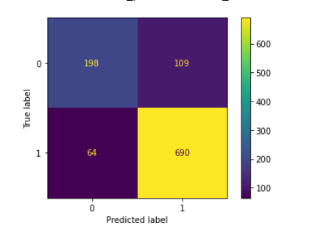

Classification Report:

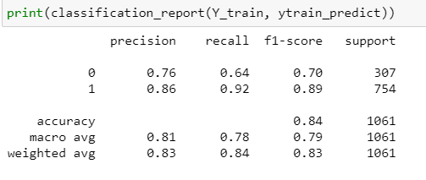

Confusion matrix:

For test data:

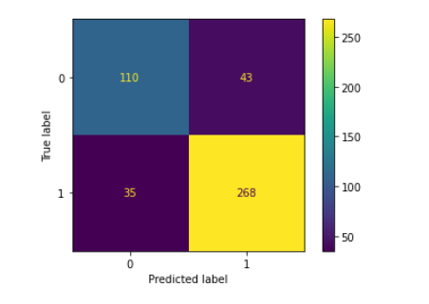

Classification Report:
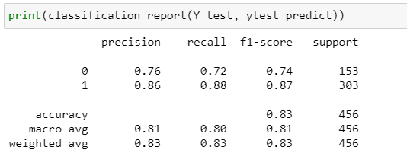

Conclusion:
The accuracy of the model on train data is low than that of test data, that means the model is good to go.
The recall and f1 score also good in case of training data.

Area under curve and roc for the training data:
For train data:

AUC: 0.890

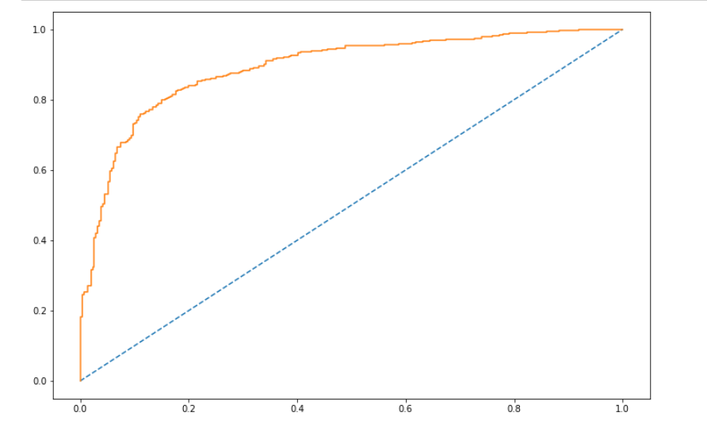

For test:
Accuracy score: 0.8289473684210527

AUC: 0.880

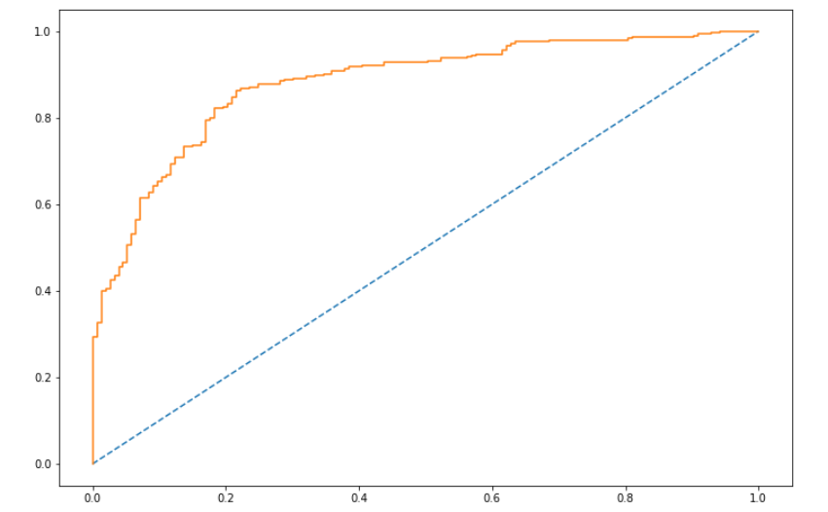

Linear Discriminant Analysis:

Imported LinearDiscriminantAnalysis from sklearn, and split the dataset into train and test set in 80:20 ratio.
Fitting the x_train and y_train into LDA classifier and then predicted the class for x_train and x_test.
Now, let see the classification report for the training and testing dataset:

Classification Report for training and testing dataset:
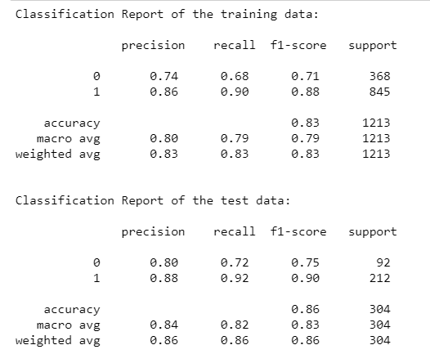

Let’s check the Area under curve for training and test data set:
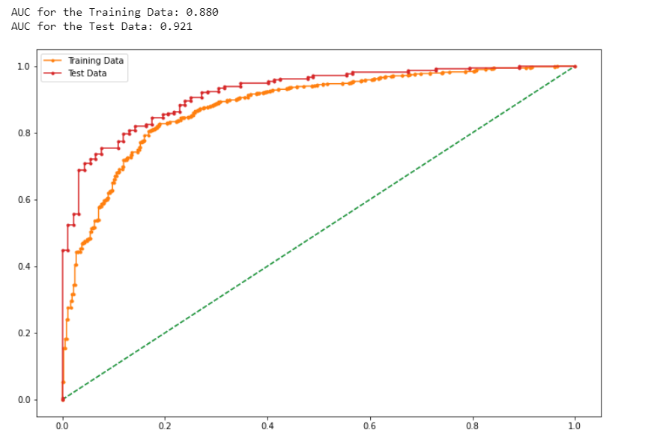

Conclusion:
The accuracy of the model for the train data is 83% and for the testing data is 86%.
Recall and f1 score is also pretty good in testing data.

KNN model:

For KNN model, first we scale the data, because KNN model requires data to be scaled. Here we are using zscore to scale the data.
After separating the independent and dependent variables into X and Y, we will be scaling the numeric and categorical data values.

Checking the head of independent variables.

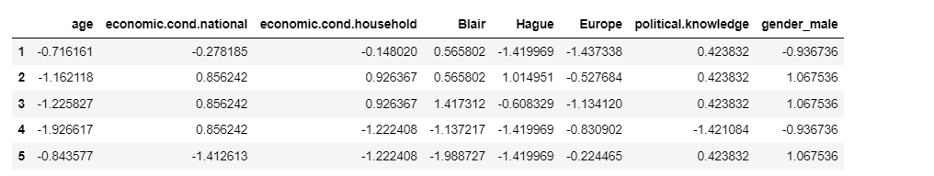

Importing the KNeighbourClassifier from sklearn.neighbors then fitting the X_train and Y_train to the model.
KNN model score: 0.85

Confusion Matrix and Classification Report:
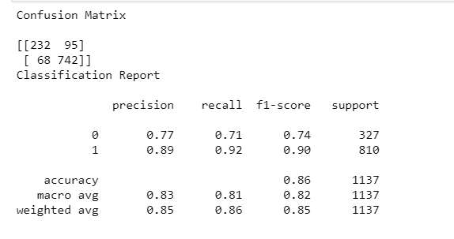

Area Under Curve :

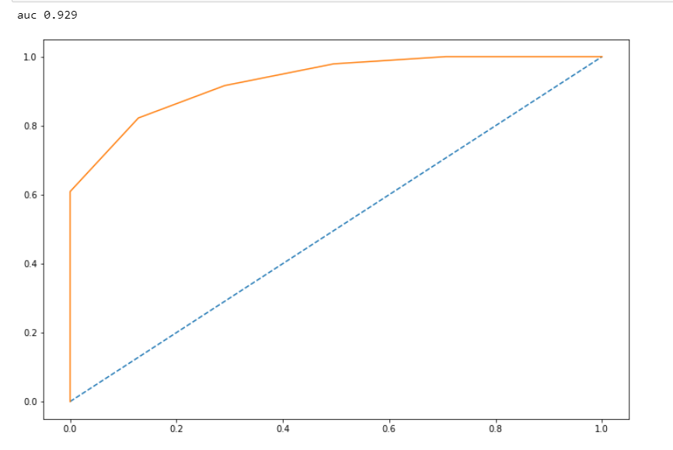

Naïve Bayes model: Naïve Bayes does not need features to be scaled, that’s why we won’t scale our data.
So after separating the independent and dependent variables into X and Y and splitting into train and test set into 70:30 ratio.

Checking the head of X_train:
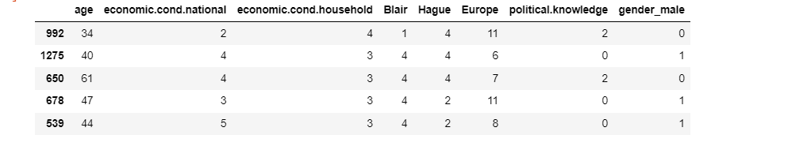
After fitting the model into x_train and y_train we will see the performance of our model on train and test data.
Model accuracy on training data: 84%
Model accuracy on test data: 82%

Confusion Matrix and Classification Report:

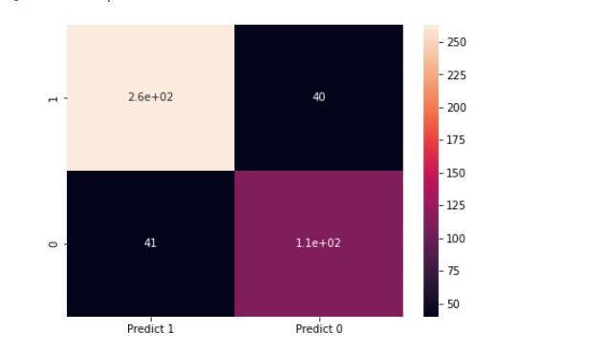
Classification Report:
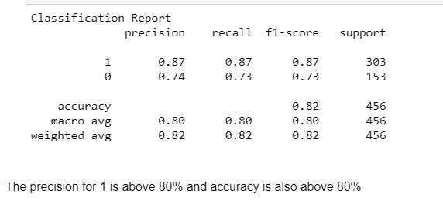

Model Tuning, Bagging (Random Forest will be applied for Bagging) and Boosting:

First we will importing RandomForestClassifier from sklearn.ensemble.
Checking the head of the data after get dummies.

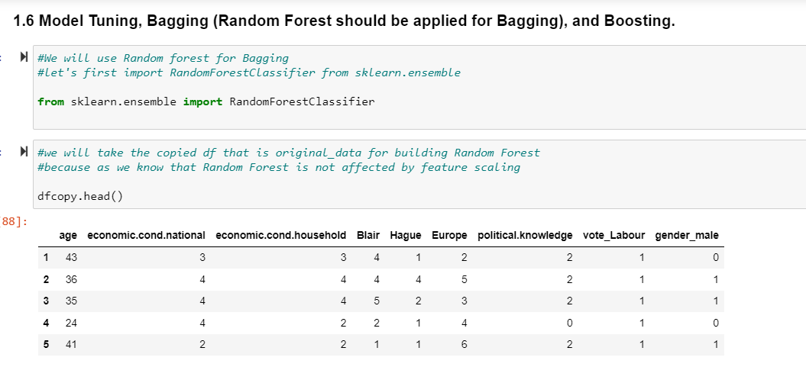

Info of the dataset:
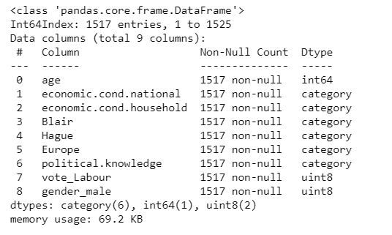

Note:
n_estimators is the number of trees, that we want to build within the Random Forest Classifier. Out of bag (oob) score is a way of validating the random forest model. OOB score is computed as the number of correctly predicted rows from the out of bag sample. Max_features will be used to select randomly features from the available number of features.

Rfcl.oob_score is 0.823751178133836

Error_rate(in %) : 0.17624882186616397
For the above specified grid parameters, we got the rfcl model with oob score 80.6% and error rate 19.3%, which shows the model is good to go for further evaluation.

Feature importance:

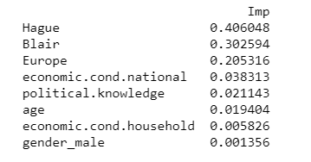
Hague and Blair are the features in the dataset with most importance.

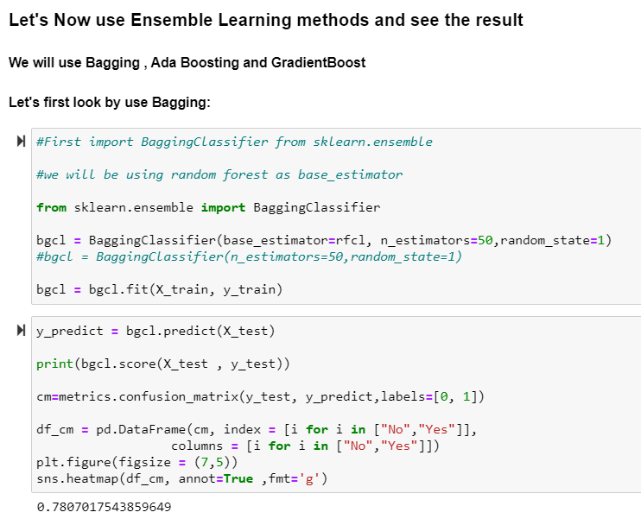
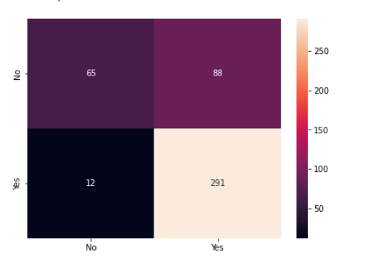

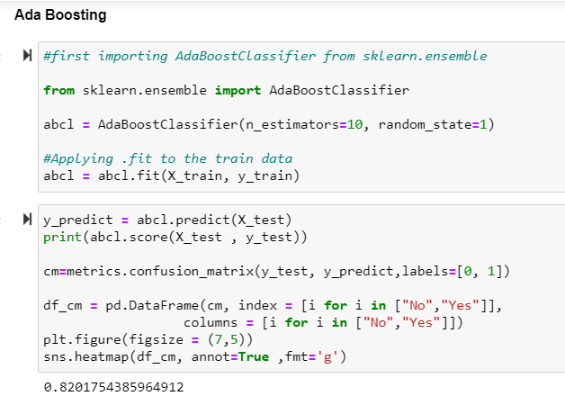

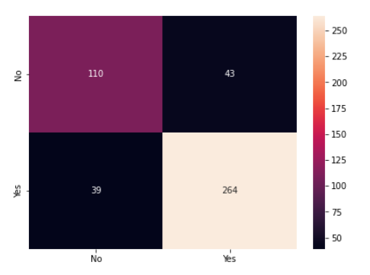

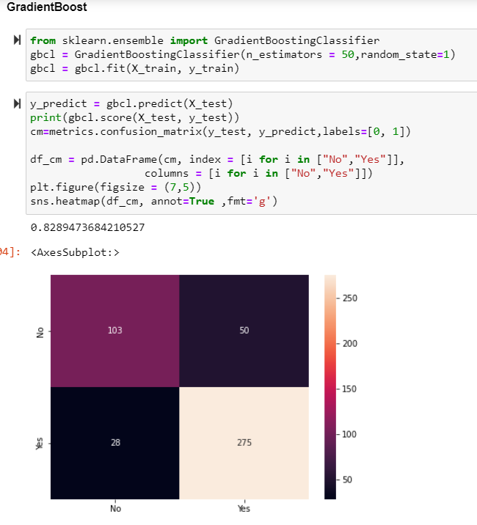

1.7 performance metrics: check the performance of predictions on train and test sets using accuracy, confusion matrix, plot roc curve and get roc_auc score for each model. Final model: compare the models and write inference which model is best/optimized. (7 marks)
#performance metrics has already been performed on models
Logistic regression: for logistic regression on train data, we can see the below classification report:
The intention behind using logistic regression is to find the best fitting model to describe the relationship between the dependent and the independent variable.
The accuracy and recall value on the train data is above 80% which is a good indication for the labour party.
precision recall f1-score support

0 0.76 0.64 0.70 307
1 0.86 0.92 0.89 754

Accuracy 0.84 1061
Macro avg 0.81 0.78 0.79 1061 weighted avg 0.83 0.84 0.83 1061
Same model when fit on test data:
precision recall f1-score support

0 0.76 0.72 0.74 153
1 0.86 0.88 0.87 303

Accuracy 0.83 456
Macro avg 0.81 0.80 0.81 456 weighted avg 0.83 0.83 0.83 456
For train data, area under curve (auc) = 89%
And for test data , auc: 88%

For linear discriminant analysis
In linear discriminant analysis (lda):
Classification report of the training data:
precision recall f1-score support

0 0.74 0.68 0.71 368
1 0.86 0.90 0.88 845

Accuracy 0.83 1213
Macro avg 0.80 0.79 0.79 1213 weighted avg 0.83 0.83 0.83 1213
Classification report of the test data:
precision recall f1-score support

0 0.80 0.72 0.75 92
1 0.88 0.92 0.90 212

Accuracy 0.86 304
Macro avg 0.84 0.82 0.83 304 weighted avg 0.86 0.86 0.86 304
Auc for the training data: 88% auc for the test data: 92%

For knn model:
The model score is 85%
Classification report:
precision recall f1-score support

0 0.77 0.71 0.74 327
1 0.89 0.92 0.90 810

Accuracy 0.86 1137
Macro avg 0.83 0.81 0.82 1137 weighted avg 0.85 0.86 0.85 1137
Auc on train data = auc 0.929

Naive bayes:
In train data model accuracy model accuracy: 0.84
On test data model accuracy: 0.82
Classification report:
precision recall f1-score support

1 0.87 0.87 0.87 303
0 0.74 0.73 0.73 153

Accuracy 0.82 456
Macro avg 0.80 0.80 0.80 456 weighted avg 0.82 0.82 0.82 456
The precision for 1 is above 80% and accuracy is also above 80%.

1.8 based on these predictions, what are the insights?
Insights:
By looking at the insights from the above predictions, we can confidently say that labour party would be the first choice to win in the elections. Below are some insights:
We can see that the labour party will get more number of votes that the conservative party.
Blair, who is the leader from labour party has received good ratings than The Hague from conservative party.
On a scale of 1 to 5, Blair has got rating 4 more than Hague in the assessment.
Female candidates are more active in voting than male.
Age does not have much impact on the result.
In all the models and their prediction on test data, the classification report seems to be in favor of 1(labour party votes)
On the basis of calculations based on current economic household condition and national economic condition, the labour party has got better performance representation than its opponent party.

MACHINE LEARNING

Problem 2:
In this particular project, we are going to work on the inaugural corpora from the nltk in Python. We will be looking at the following speeches of the Presidents of the United States of America:
- President Franklin D. Roosevelt in 1941
- President John F. Kennedy in 1961
- President Richard Nixon in 1973
LOADING THE DATA:
Importing all the required libraries and package.
Importing nltk (Natural Language Tool Kit) and string.
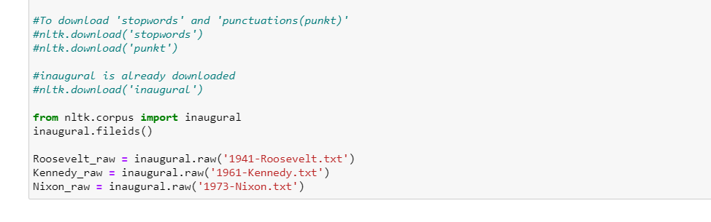
Now, let’s check length of all 3 files:
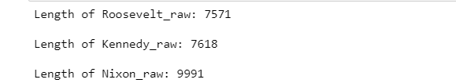

The variable 'Roosevelt_raw' contains a string with 7571 characters, Kennedy_raw contains 7618 characters, and Nixon_raw contains 9991 characters. This is the raw content of the speech, including many details we are not interested in such as whitespace, line breaks and blank lines. Notice the \r and \n in the opening line of the file, which is how Python displays the special carriage return and line feed characters. For our language processing, we want to break up the string into words and punctuation. This step is called tokenization, and it produces our familiar structure, a list of words and punctuation.

Removing unwanted characters:
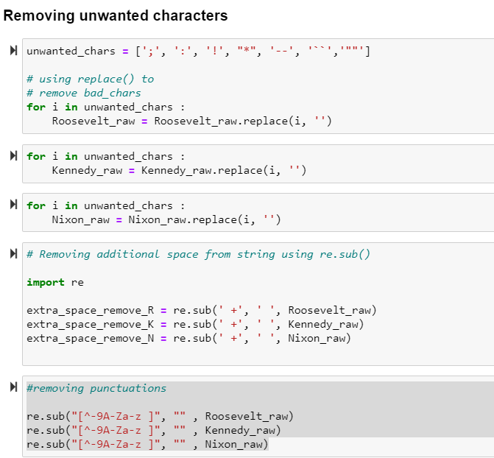

Converting all upper case words to lower case:
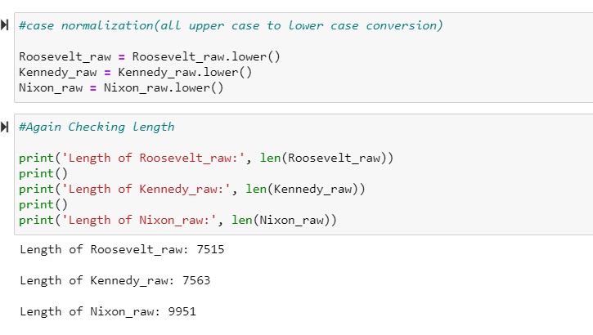
Checking the length of the token after tokenization:

length of tokens: 1492
['on', 'each', 'national', 'day', 'of', 'inauguration', 'since', '1789', ',', 'the']
-------------------------------------
length of tokens: 1512
['vice', 'president', 'johnson', ',', 'mr.', 'speaker', ',', 'mr.', 'chief', 'justice']
-------------------------------------
length of tokens: 1983
['mr.', 'vice', 'president', ',', 'mr.', 'speaker', ',', 'mr.', 'chief', 'justice']

Checking Number of sentences in all 3 speeches:
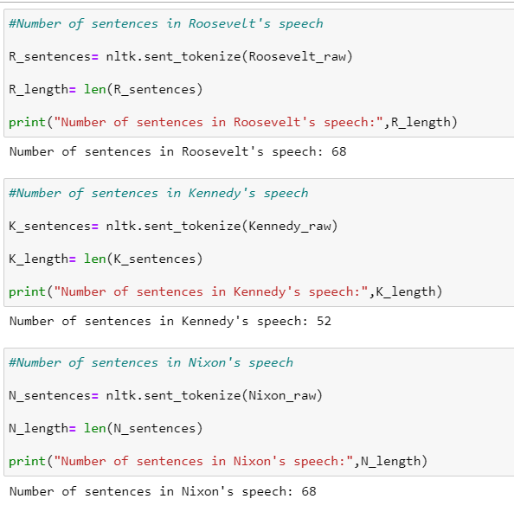

Checking texts from R_text:

['the', 'democratic', 'aspiration', 'is', 'no', 'mere', 'recent', 'phase', 'in', 'human', 'history', '.', 'it', 'is', 'human']
------------------------------

Checking texts from K_text:

['area', 'in', 'which', 'its', 'writ', 'may', 'run', '.', 'finally', ',', 'to', 'those', 'nations', 'who', 'would', 'make', 'themselves', 'our', 'adversary', ',']
------------------------------

Checking texts from N_text:

['to', 'new', 'has', 'not', 'been', 'a', 'retreat', 'from', 'our', 'responsibilities']

Checking the predefined set of stopwords:
Stopwords
['i', 'me', 'my', 'myself', 'we', 'our', 'ours', 'ourselves', 'you', "you're", "you've", "you'll", "you'd", 'your', 'yours', 'yourself', 'yourselves', 'he', 'him', 'his', 'himself', 'she', "she's", 'her', 'hers', 'herself', 'it', "it's", 'its', 'itself', 'they', 'them', 'their', 'theirs', 'themselves', 'what', 'which', 'who', 'whom', 'this', 'that', "that'll", 'these', 'those', 'am', 'is', 'are', 'was', 'were', 'be', 'been', 'being', 'have', 'has', 'had', 'having', 'do', 'does', 'did', 'doing', 'a', 'an', 'the', 'and', 'but', 'if', 'or', 'because', 'as', 'until', 'while', 'of', 'at', 'by', 'for', 'with', 'about', 'against', 'between', 'into', 'through', 'during', 'before', 'after', 'above', 'below', 'to', 'from', 'up', 'down', 'in', 'out', 'on', 'off', 'over', 'under', 'again', 'further', 'then', 'once', 'here', 'there', 'when', 'where', 'why', 'how', 'all', 'any', 'both', 'each', 'few', 'more', 'most', 'other', 'some', 'such', 'no', 'nor', 'not', 'only', 'own', 'same', 'so', 'than', 'too', 'very', 's', 't', 'can', 'will', 'just', 'don', "don't", 'should', "should've", 'now', 'd', 'll', 'm', 'o', 're', 've', 'y', 'ain', 'aren', "aren't", 'couldn', "couldn't", 'didn', "didn't", 'doesn', "doesn't", 'hadn', "hadn't", 'hasn', "hasn't", 'haven', "haven't", 'isn', "isn't", 'ma', 'mightn', "mightn't", 'mustn', "mustn't", 'needn', "needn't", 'shan', "shan't", 'shouldn', "shouldn't", 'wasn', "wasn't", 'weren', "weren't", 'won', "won't", 'wouldn', "wouldn't"]

Again checking the length of tokens:
length of tokens: 1492
['on', 'each', 'national', 'day', 'of', 'inauguration', 'since', '1789', ',', 'the']
-------------------------------------
length of tokens: 1512
['vice', 'president', 'johnson', ',', 'mr.', 'speaker', ',', 'mr.', 'chief', 'justice']
-------------------------------------
length of tokens: 1983
['mr.', 'vice', 'president', ',', 'mr.', 'speaker', ',', 'mr.', 'chief', 'justice']

Checking the top 3 Most Frequent words:
For Roosevelt speech: Nation, know and Spirit.
[('nation', 12), ('know', 10), ('spirit', 9)]

For Kennedy: let, us and world.
[('let', 16), ('us', 12), ('world', 8)]

For Nixon: us, let and America
[('us', 26), ('let', 22), ('America', 21)]

Making the word cloud for all 3 speeches:

1. For Roosevelt:

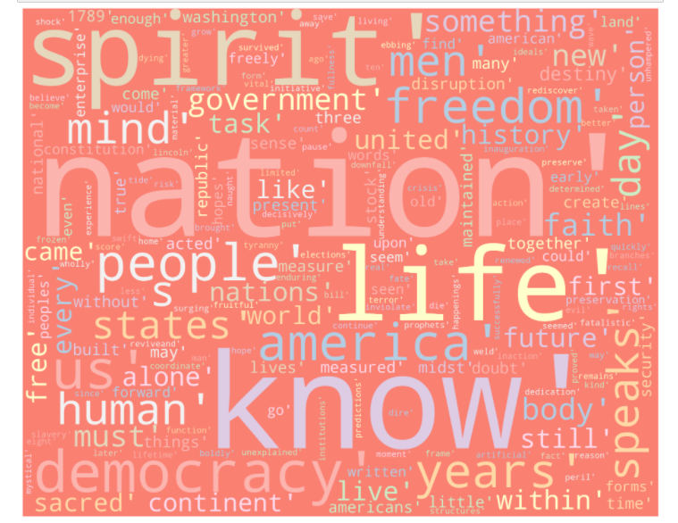

2. For Kennedy:

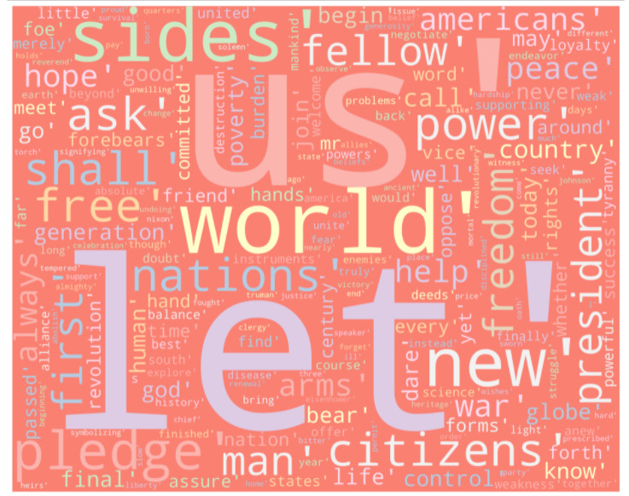

3. For Nixon:
